**Manuals for ‘Manage Trustees/Management’**

**Brief of the ‘Manage trustees/management’ –** This is the page where we manage trustees/management users profile.

**1. How to manage trustees/management** **-.**

Steps:

1. Login to the site and go to ‘Masters’ tab and click on ‘Manage trustee/management’.
2. On this page trustee and management user list and ‘Add new management/trustee’ button will display.
3. We can edit and delete the existing record on clicking ‘edit’ and ‘delete’ icon.
4. Click on ‘Add new management/trustee’ button for add new records.
5. The added new record will display with respective management and trustees page.

1.

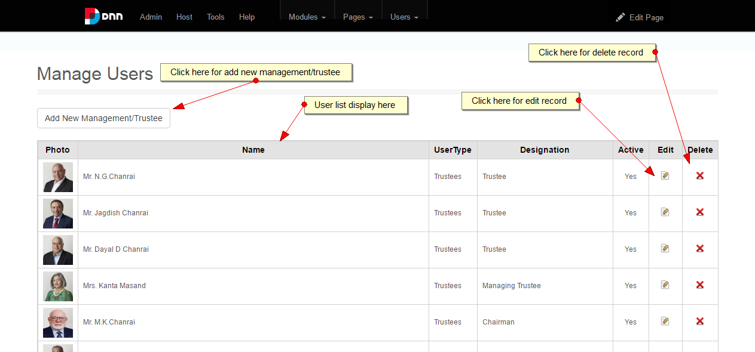

2.

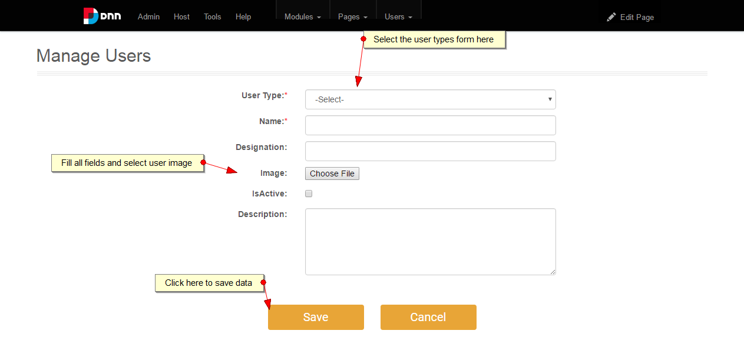

3.

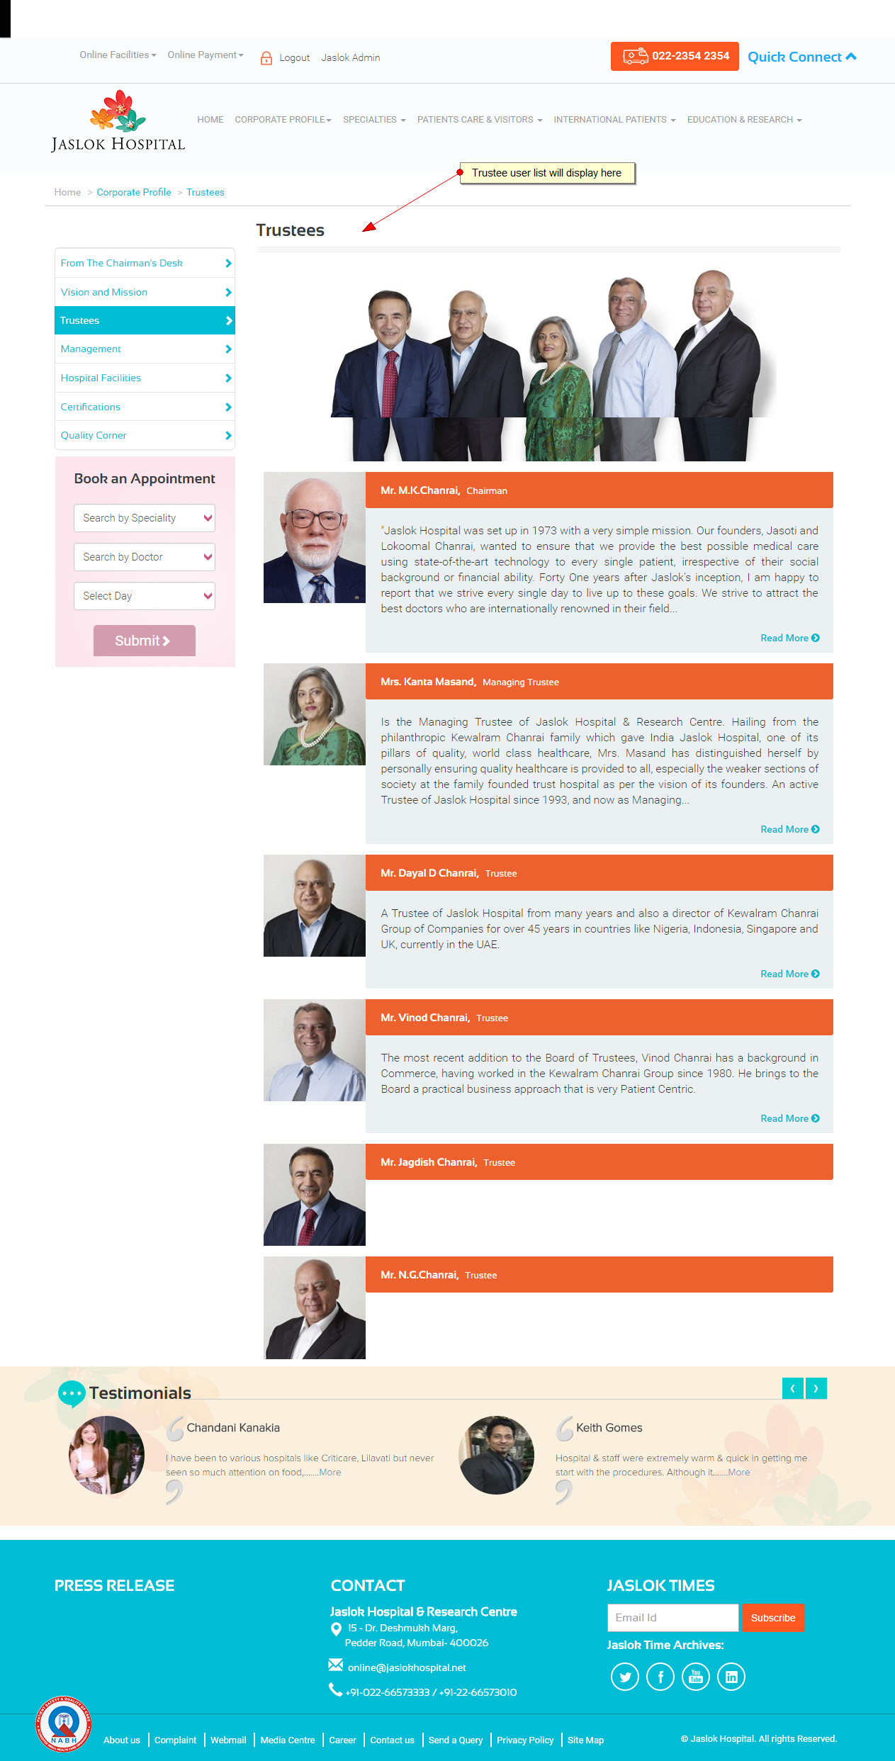

4.

